Created file
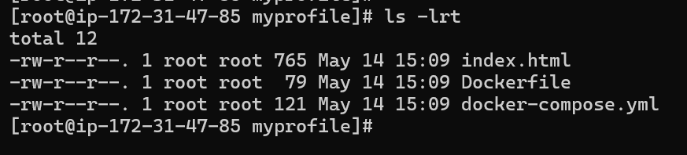

Container Running

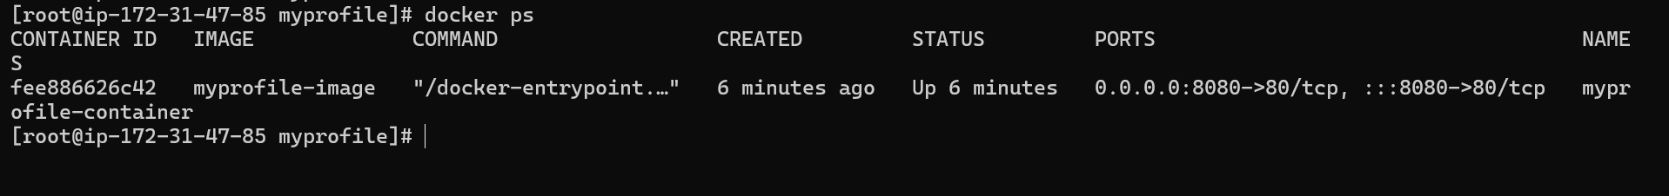

Created Docker Webpage(http://13.206.190.189:8080/)
